Proposal for AI-powered classification of the diabetic retinopathy severity

**Institution:** Saskatchewan Polytechnic

**Course:** Capstone Project

**Instructor:** Himanshu Patel ([patelh@saskpolytech.ca](mailto:patelh@saskpolytech.ca))

**Submitted by:**

Thanh Thao Nguyen ([nguyen53661@saskpolytech.ca](mailto:nguyen53661@saskpolytech.ca))

1. **INTRODUCTION**

**Diabetic Retinopathy** is a complication of diabetes resulting from damage to the blood vessels in the eyes. The Diabetic Retinopathy classification plays a vital role in treatment from an early period. The advancement of Artificial Intelligence can help to classify and enhance treatment in accuracy, efficiency, and quickness.

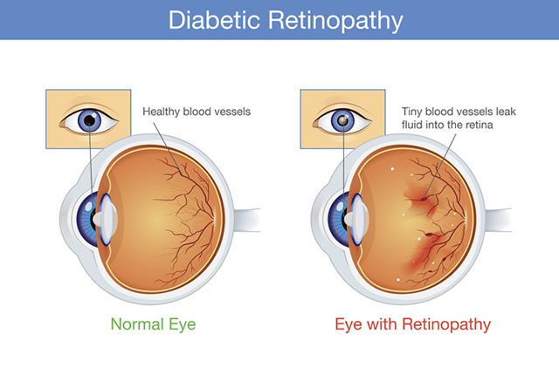

*Note.* **Comparison between Normal Eye and Eye with Retinopathy**. From *Diabetic Retinopathy* [Photograph], by Bobbi Nodell, 2020, (<https://newsroom.uw.edu/news-releases/ai-technology-doesnt-reliably-detect-diabetic-eye-disease>). 206.543.7129

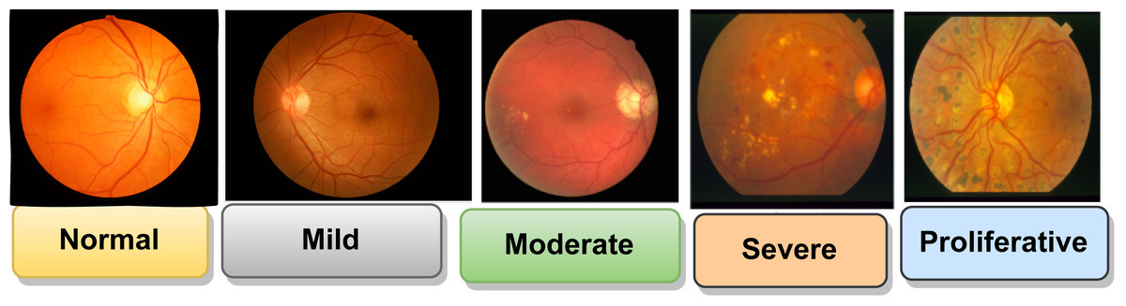

*Note*. **The severity of Diabetic Retinopathy ranges from Normal to Proliferative**. From *Stages of DR* [Photograph], by Prasanna Porwal, Samiksha Pachade, Ravi Kamble, Manesh Kokare, Girish Deshmukh, Vivek Sahasrabuddhe, Fabrice Meriaudeau, April 24, 2018, “Indian Diabetic Retinopathy Image Dataset (IDRiD)”, IEEE Dataport, <https://dx.doi.org/10.21227/H25W98>, (<https://peerj.com/articles/cs-1947/>). CC BY 4.0 DEED.

1. Project Overview

This project aims to develop a deep learning model to support the Diabetic Retinopathy classification via retinal high-resolution images with the following goals:

* **Efficiency:** Automatic classification can screen twice as many patients as the traditional method.
* **Accuracy:** It achieves 90% accuracy of classification at the early stage.
* **Real-world application:** It reduces classification time, helps patients be treated early, and improves the quality of patients’ lives.
* **Reliability:** It needs to be updated continuously.
* **Scalability:** It can find out other eye diseases except Diabetic Retinopathy.

1. Problem Statement

The accurate and early classification of Diabetic Retinopathy can prevent more serious complications, reduce treatment pressure, save medical costs, and improve the quality of patients’ lives. However, classification can face some particular challenges, leading to difficulty in determining severity and providing a treatment regimen.

* The diversity of disease stages ranges from the normal stage to the proliferative stage.
* The presence of associated risk factors, such as duration of diabetes, blood sugar levels, high blood pressure, hyperlipidemia, and kidney problems.
* Each patient has a different disease manifestation, even though they are in the same stage.

This project aims to overcome the above limitations by using a deep learning model to classify diseases accurately and quickly via retinal high-resolution images.

1. Research Questions/ Hypotheses

Some research questions and hypotheses are given below:

* **Research Question 1:** How accurately does a deep learning model classify Diabetic Retinopathy compared to how a doctor classifies it?
* **Research Question 2:** What are the deep learning architectures used for classifying Diabetic Retinopathy?
* **Research Question 3:** How sustainably does a deep learning model perform when applied to retinal images from different patients and devices?
* **Hypothesis 1:** A deep learning model trained on retinal high-resolution images can achieve 90% accuracy of classification.
* **Hypothesis 2:** A deep learning model is flexible to use with different patients and devices.

1. **LITERATURE REVIEW:**

Below is a summary of relevant literature, key findings, and gaps in existing research:

**Diabetic Retinopathy Classification by Doctors**

There are two steps as follows:

* **General Eye Exam:** vision test, check eye pressure and other parts of the eyes, apply mydriatics (this medicine makes the small round black area at the centre of the eye larger).
* **Detect the image of the bottom of the eyes:** take a photo of the bottom of the eyes in colour, use fluorescent substances to find out abnormal blood vessels, and see the detailed structures of the retina.

**Diabetic Retinopathy Classification by Deep Learning Model**

A Convolutional Neural Network (CNN) model is used for image segmentation. Models such as ResNet, DenseNet, EfficientNet, and Vision Transformer can be used for feature extraction. Model EfficientNet is the best choice. A Recurrent Neural Network (RNN) is used for image captioning.

**Existing Research and Benchmarks**

**A deep learning based model for diabetic retinopathy grading** (30 January 2025): Develop a new deep learning model named RSG-Net to classify Diabetic Retinopathy based on retinal images. The limitation of this model is that it is tested on one dataset. It may not work if applied to different images from different resources or devices.

**Diabetic retinopathy classification using a multi-attention residual refinement architecture** (10 August 2025): Improve a deep learning architecture named “multi-attention residual refinement” to classify Diabetic Retinopathy. It uses a huge dataset (EyePACS) of retinal images, including clinical photos and unclear photos, to improve practicality and stability.

1. **PROJECT METHODOLOGY**

This project develops a deep learning model of Diabetic Retinopathy classification via retinal high-resolution images. The methodology includes the following key phases:

1. Dataset Collection

Retinal high-resolution images are taken from three datasets as follows:

**Diabetic Retinopathy 224x224 (2019 Data)** with the link: <https://www.kaggle.com/datasets/sovitrath/diabetic-retinopathy-224x224-2019-data>

**Diabetic Retinopathy Unziped** with the link: <https://www.kaggle.com/datasets/saipavansaketh/diabetic-retinopathy-unziped>

**eye_diseases_classification** with the link: <https://www.kaggle.com/datasets/gunavenkatdoddi/eye-diseases-classification>

1. Data Preprocessing

* Resize image for standardization
* Identify and handle missing data
* Reduce the quantity of photos which is unclear or have no labels

1. Data Analysis

* Analyze a dataset's statistics, such as image resolution, class distribution
* Identify potential issues, such as imbalanced classes

1. Model Selection

* **Deep Learning Model:** With the need for good image segmentation in a large dataset, EfficientNet is the best choice. Below is the comparison table between four models:

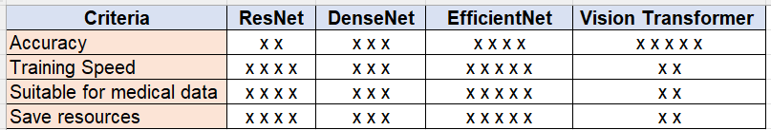

* **Libraries**: Python, NumPy, Matplotlib, Scikit-learn.

1. Evaluation

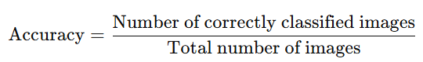

1. **PROJECT TIMELINE**

The project will be implemented within 3 and a half months, divided into 2 milestones:

* **Milestone 1**: Baseline Model Development
* **Milestone 2**: Model Optimization Deployment

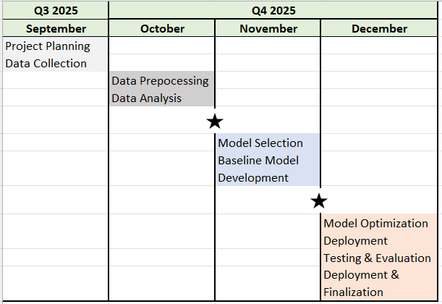

1. **CONCLUSION**

This project aims to develop a deep learning model EfficientNet using for Diabetic Retinopathy classification via retinal high-resolution images. The steps, such as data preprocessing, model training, and evaluation, are implemented to create accurate and efficient classification. The proposal has the potential to reduce classification time, patients can have good treatment, and improve their life quality.

1. **REFERENCES**

**Samia Akhtar, Shabib Aftab, Oualid Ali, Munir Ahmad, Muhammad Adnan Khan, Sagheer Abbas & Taher M. Ghazal**. (30 January 2025). A deep learning based model for diabetic retinopathy grading. *Scientific Reports,* volume 15, Article number: 3763 (2025).<https://www.nature.com/articles/s41598-025-87171-9>.

**Zijian Wang, Yi Wang, Chun Ma, Xuan Bao & Ya Li.** (10 August 2025). Diabetic retinopathy classification using a multi-attention residual refinement architecture. *Scientific Reports*, volume 15, Article number: 29266 (2025). <https://www.nature.com/articles/s41598-025-15269-1>